Note: This “manuscript template” is compiled from multiple articles, and the content may be discontinuous. It is provided only for reference when adjusting the formatting. All explanatory notes must be deleted before formal submission.

When uploading your manuscript, please also upload a compressed file containing the original images that can be edited in PPT, and provide a clear image that can represent the content of the article (TOC graphic).

Please strictly format your manuscript according to the requirements of the “Manuscript Template” (Word document) available in the Download Center on the journal’s website. After the English abstract, use a double-column layout and single line spacing. Use size-5 font for the main text, size-9 font for the abstract, figure/table captions, and references, and size-6 font for text inside tables. Unless otherwise specified, Chinese text should be in SongTi, while English letters and numbers should be in Times New Roman. The entire manuscript must use single line spacing, with zero spacing before and after paragraphs. To avoid affecting the acceptance of your submission, please revise strictly according to the template!!!

中文题目(In bold, size-3 SongTi; the Chinese title should not exceed 20 characters; the Chinese and English titles must correspond; abbreviations should not be used)

李某，冯某某^{*2}（The number of authors should not exceed seven; different affiliations should be indicated with superscript numbers 1, 2, 3 in Times New Roman; for secondary units under the same primary institution, use a, b, c for distinction; all fonts should be in size-5 KaiTi）
(1. 华东理工大学 a.化学与分子工程学院；b. 上海市功能性材料化学重点实验室，上海 200237；2. 上海商学院 食品系，上海 200235)（In small size-5 SongTi）

摘要：目的·□□□□□□□□□□□□□□□□□□□□□□□□□□□□□□□□□□□□□□□□ 方法·□□□□□□□□□□□□□□□□□□□□□□□□□□□□结果·□□□□□□□□□□□□□□□□□□□□□□□□□□□□□□□□□□□□□□□结论·□□□□□□□□□□□□□□□□□□□□□□□□□□□□□□□
(1.The abstract should include four elements: objective, methods, results, and conclusions. It must be a complete and citable short text with self-explanatory, independent, and concise characteristics, and should not contain figures, tables, or reference. 2. It must be written in the third person, and subjective expressions such as “this paper,” “our research group,” or “we” are not allowed. 3. The Chinese abstract should contain 400–500 characters and use small size 5 SongTi. 4. When an abbreviation appears for the first time, its full term must be provided. Commonly used equipment names or testing methods that are well known may be directly expressed with standard abbreviations (e.g., XRD/SEM/TEM).)
关键词：关键词1；关键词2；关键词3；关键词4；关键词5（The keywords section should contain 5–8 keywords, separated by semicolons. To improve retrieval efficiency, please select terms that occur frequently in the relevant field. Chinese and English keywords must correspond one-to-one.）
中图分类号：(Refer to the Chinese Library Classification: O61 – Inorganic Chemistry, O62 – Organic Chemistry, O63 – Polymer Chemistry, O64 – Physical Chemistry, O65 – Analytical Chemistry, O69 – Applied Chemistry)
文献标识码：A 文章编号：

Comparison of the Determination of 117 Component VOCs Simultaneously Using Online and Canister Sampling Method（The title should be in bold, size-5 font, and all major words should be capitalized except prepositions.） LI Mou¹, FENG Mou-mou^{*2} Author names: written in Hanyu Pinyin, with surname first and given name after it; the surname in all capital letters, the given name with only the initial letter capitalized; for two-syllable given names, connect the syllables with a hyphen; italic, small size-5 font. (1a.School of Chemistry and Molecular Engineering, 1b.East China University of Science and Technology, Shanghai Key Laboratory of Functional Materials Chemistry, Shanghai 200237, China; 2. The Department of Food, Shanghai Business School, Shanghai 200235, China)
Abstract：Objective·□□□□□□□□□□□□□□□□□□□□□Methods·□□□□□□□□□□□□□□□□□□□Results·□□□□□□□□□□□□□□□□□□□□□□Conclusion·□□□□□□□□□□□□□□□□□

（It should include four parts: objective, methods (past passive voice), results, and conclusion (present tense). Pay attention to tense and expression in the English abstract; simplify the wording as much as possible, use short sentences, and avoid monotonous structures. Be careful with the use of articles—do not misuse or omit them arbitrarily. British or American spelling is acceptable, but must be consistent throughout the manuscript.）
Key words：keyword 1; keyword 2; keyword 3; keyword 4; keyword 5 English keywords must correspond one-to-one with the Chinese keywords, begin with lowercase letters, and be separated by semicolons.

(The introduction section should not be numbered. The main text should use size-5 font. The introduction must be clearly distinguished from the conclusion, and attention should be paid to the timeliness of cited references.)
The introduction needs to clearly describe the current global state of the art in the reported research field, identify existing problems, specify the entry point of the research work, and explain how this work contributes to the technological progress of the field. The introduction must answer two questions: Why is this study necessary? What is the novelty of the work? Its content should not overlap with the abstract or the conclusion. It is preferable not to include figures or tables.李刚等^{[11]}（when referring to authors of cited literature, use “*等” after the first author; do not use expressions equivalent to “*等人”）以植物乳杆菌……。Kwaw等^{[12]}研究了……影响。

1 实验部分（The hierarchical numbering in the text should use Arabic numerals and be arranged in the form “1”, “1.1”, “1.1.1”.）
Primary headings should be in size-5 SongTi, with both the numbering and the heading in bold. Experimental section headings follow a fixed format. Leave two spaces between the number and the title. Leave one blank line between a primary heading and the preceding text.
1.1 主要仪器与试剂
Secondary and lower-level headings should be in size-5 SongTi, with only the numbering in bold. “Main Instruments and Reagents” is a fixed heading. Leave two spaces between the number and the title.
Instrument writing order: model – instrument name (manufacturer). Different instruments should be separated by semicolons; for instruments from the same manufacturer, use commas. For foreign instruments, indicate the country.
例：AUW220D型电子分析天平（日本Shimadzu有限公司）；JJ-1型磁力电动搅拌器（金坛市富华仪器有限公司）。
Reagent writing order: reagent 1 (purity, manufacturer); reagent 2, reagent 3, reagent 4 (purity, manufacturer). Different reagents from different manufacturers should be separated by semicolons; reagents from the same manufacturer should be separated only by commas.
甲酰胺（FA）、乙醇（C₂H₅OH）（西陇化工股份有限公司）；氯化亚铁（FeCl₂，上海阿拉丁生化科技股份有限公司）；所用试剂均为分析纯。
1.2 实验方法

1.2.1 XXXXX化合物/物质的制备（The full name of a compound should be provided when it appears for the first time. It may be referred to as “化合物1” thereafter.）
例：将15.2 g（0.1 mol）（the mass is written first, followed by the amount of substance）水杨酸甲酯（1）溶于120 mL丙酮中，得15.66 g浅黄色油状液体，产率94.3%，纯度99.2%，m.p.237 ~ 239 ℃。
Note on writing format: The characterization of compounds and materials must strictly follow the format below, with attention paid to punctuation:
HNMR(CDCl₃，400 MHz)，δ：12.68(s, 1H, J=…, —OH)；… 。元素分析，（分子式），实测值（计算值），%：C 62.89（62.85）；H 10.05（10.11）…。
IR（KBr），ν，cm⁻¹：……….。MS，m/z（%）：260[M⁺，100]。ESI-MS，m/z：293.88 [M+H]⁺。Chinese punctuation marks should be used consistently throughout
1.2.2 表征/测试方法
按所定标准制备方法制备供试品溶液，取同一供试品溶液，连续进样6次，按1.2.1When using “按……”，if the preceding text refers to a condition or a heading, the heading must be in bold条件进行色谱指纹图谱测试。
电化学测试：CV的扫描速率为100 mV/s。ORR极化曲线是通过使用线性扫描伏安法在400、625、900、1225、1600和2025 r/minWhen multiple numbers share the same unit, the unit should be retained only after the last number.的速度下以5.0 mV/s的扫描速率在RDE测量得到的。
按照文献[20]When following the method of a certain reference, the citation should be placed inline.方法制备Mp。

2 结果与讨论

2.1 制备/合成条件优化
Figure requirements: （The data in the figures must be consistent with the text.）
1. All figures in the article must have figure numbers and Chinese/English captions. The Chinese and English captions must correspond, and the figure and its caption should appear in the same column. “图1，Fig. 1” should be in bold; others should not. The font size should be small 5 size.
2. For coordinate plots, both the starting and ending points of the x- and y-axes must have ticks and numerical labels. Photographic images must be clear. Both axes must have titles and units.
3. All labels inside the figures must be in English.

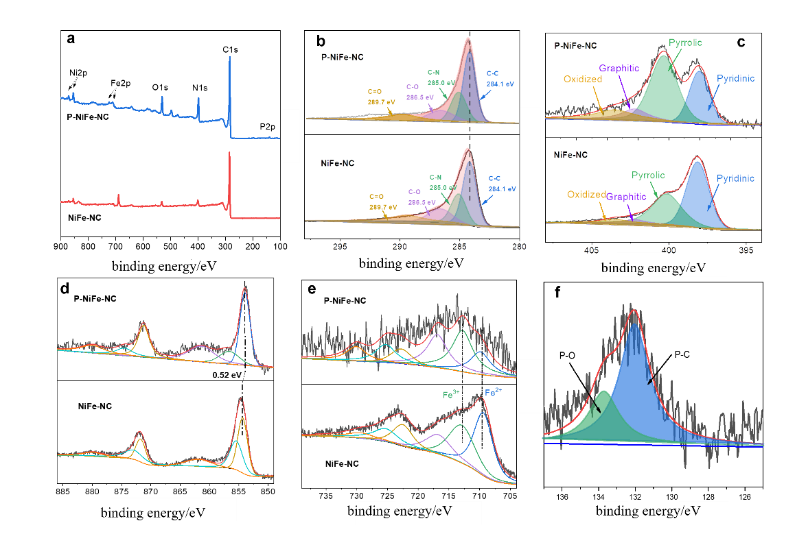
a. XPS全谱图; b. C1s谱图; c. N1s谱图; d. Ni2p谱图; e. Fe2p谱图; f. P2p谱图
图1 P-NiFe-NC和NiFe-NC的XPS结果
Fig.1 XPS results of P-NiFe-NC and NiFe-NC
（To improve visual appearance, figures should preferably be placed across two columns. Authors may choose full-width placement when appropriate. The font size and units within figures must remain uniform.）

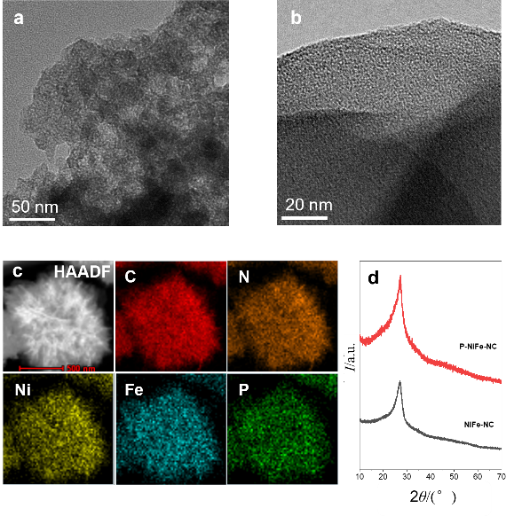
a. P-NiFe-NC的TEM图；b. P-NiFe-NC的HR-TEM图；c. P-NiFe-NC的HR-TEM图及元素能谱扫描图；d. 样品的XRD图，1. NiFe-NC，2. P-NiFe-NC（The figure notes should use size-6 font.）
图2 P-NiFe-NC的表征图
Fig.2 Characterizations of P-NiFe-NC sample

Variable symbols on the coordinate axes should be separated from their units by “/”. If a variable has more than one unit, they should be enclosed in parentheses, e.g., 浓度/(μmol·L⁻¹). Title/unit (units in lowercase letters).

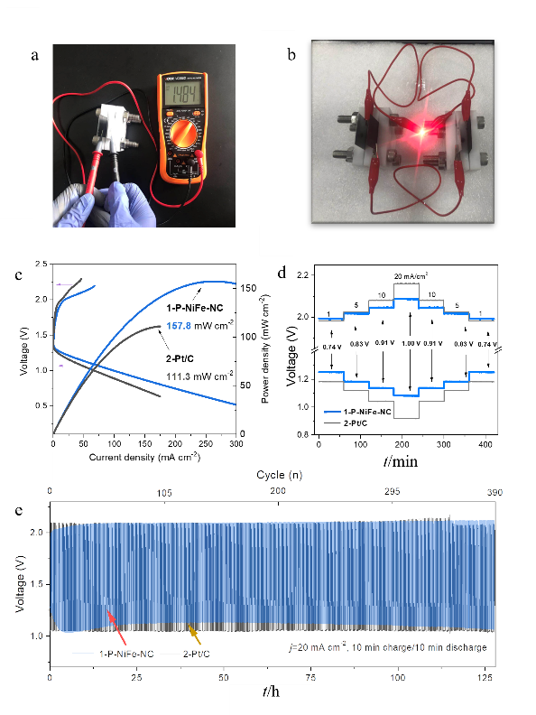
1. P-NiFe-NC；2. Pt/C
a. 开路电压测量；b. 锌-空气电池示意图；c. 充电/放电极化曲线和功率密度；d. 不同电流密度下的充放电倍率性能测试；e. 电流密度为20 mA/cm²时的长期循环性能
图3 P-NiFe-NC锌空气电池性能结果图
Fig.3 Performance results of P-NiFe-NC-assembled zinc-air battery
For composite figures, use a, b for labeling, placed inside the figure. The resolution of provided images should be ≥ 300 dpi, and images should be inserted in embedded mode.

Tables:

1.Table titles should use small size-5 font, table contents size-6 font, and tables should use the three-line format.

2.Table titles must have corresponding Chinese and English versions; double-column layout is preferred, and full-width layout may be used only if necessary.

3.If notes are included, they should be placed below the table in small size-6 font, and “Note:” should be marked at the end of the Chinese title.

4. Unit formatting should follow the same rules as figures.

5.Table titles should appear in both Chinese and English.
表1 共存干扰物及其允许量^{注}
Tab.1 Coexisting interference and the allowance
Serial number | Coexisting substance | Allowable amount of coexisting substances /mg
1 | *I^{-a} | 20
2 | S²⁻ | 25
注：ª: spiked……
Formulas: Formulas may be inserted using the equation editor or typed directly in Word. When multiple formulas appear, they should be numbered (1), (2), (3), etc. Formulas integrated within the text should use size-10.5 font; standalone formulas should use size-8 font. Notes for formulas should follow immediately after the formula, in size-6 font.
e.g., （1）
其中：J是测得的电流密度，mA/cm²；J_{K}和J_{L}是动力学电流密度和极限电流密度，mA/cm²。

3 结论
1. The conclusion should be accurate, complete, and concise. Unless special emphasis is required, conclusions already presented in the Results section should not be repeated. This section should provide new and higher-level analysis, such as the potential application prospects of the research findings, similarities or differences compared with previous studies, unresolved issues, and suggestions for future research directions. The conclusion must be clearly distinguished from the introduction.
2. The conclusion section should not include references or discussion of experimental results.

参考文献：
When citing Chinese references, both Chinese and English versions must be provided.
Notes: 1. The numbering of references at the end of the paper must correspond to the numbering in the main text.
2. References should follow the principle of citing “the most essential, the most recent, and publicly published literature that has been personally read by the authors,” and must follow standardized citation formats. Recent articles published in the journal Chemical Reagents may be consulted as examples.
3. The number of references should be within 60 and not fewer than 15, and articles from the past five years should be cited as much as possible.
4. Reference numbers must not include forms such as a, b, c, etc.
Journal format:
List all authors. Journal Title, year, volume(issue): page range. (Do not include the article title. For Chinese journals, provide both Chinese and English versions.)
For example:
- Ge Y C, Shang Y Y, Yin L, Ma Q.（Include all authors） Chem. Reagents, 2024, 46 (7): 20-28.
葛运程, 尚宇瀚, 尹磊，马强. 化学试剂, 2024, 46 (7): 20-28.
- Koley S, Dash S, Khwairakpam M, Kalamdhad A S. J. Environ. Manage, 2023, 351: 119770.
- Zhang Y Y, Han X O, Chen X, Li Y S, Cao Z B. J. Food Saf. Qual., 2019, 10 (5): 1294-1299.
张媛媛，韩晓鸥，陈曦，李延升，曹忠波. 食品安全质量检测学报, 2019, 10 (5): 1294-1299.
Monographs, collected papers, dissertations, reports:
Main responsible person(s). Title of the work. Place of publication: Publisher, year of publication. Page numbers.
For example:
- Du R H D，Gokel G W. Experimental Organic Chemistry. 2th Edition. New York: McGraw-Hill Book Company, 1986: 21-25.
- Su J. Rare Earth Chemistry . Henan: Henan Science and Technology Press, 1993.
苏锵. 稀土化学.河南: 河南科学技术出版社, 1993.
- Chen Y. UML-Based System Level Design Method ology for Embedded Systems. Shanghai: Fudan University,2005.
陈燕. 基于UML的嵌入式系统系统级设计方法研究. 上海：复旦大学，2005.

Patents:
Patent number. Patent holder(s). Publication date (YYYY-MM-DD).
For example:
- ZL881056073.Jiang X Z. 1989-07-26.
ZL881056073.姜锡洲. 1989-07-26.
- ZLEP0029602.Takashi M，Sakae T，Fumiaki M. 1980-11-21.
International and national standards:
Standard number. Standard title, publication date (YYYY-MM-DD).
For example:
- GB 3095－2012. Ambient Air Quality Standard , 2012-02-29.
GB 3095－2012. 环境空气质量标准, 2012-02-29.

Manuscript Notes:
1. Punctuation and Character Usage
1）Physical quantities should be in italic, with a space between the number and the unit.
2）Use Chinese punctuation for Chinese text and English punctuation for English text, with a space following English punctuation.
3）Mathematical operators use full-width symbols: ＋，－，×，÷，＝，＜，＞，≥，≤，±. Expressions like “all greater than (all less than, all equal to)” remain unchanged. Chemical bonds: —，＝，≡.
4）Use “~” to indicate ranges; “∶” for ratios; middle dot: •; other symbols: ℃, ', °; for Greek letters, insert from Western font Greek symbols.
5）Time units should be “s, min, h, d”; months and weeks do not need units.
6）Amount of substance concentration (abbreviated as concentration) should be expressed in mol/L or mol/m³ (do not use molar concentration M, equivalent concentration N, ppm, ppb, etc.).
7）When multiple numbers share the same unit, only the last number keeps the unit.

2. Writing Amounts and Volumes
1）n（XX）∶n（XX）＝2∶1；V（氯仿）∶V（甲醇）＝10∶1；

3. Figures in the manuscript must be clear, and the figure caption should be on the same page as the figure.

4 Common SI units:
Length: nm，μm，mm，cm，m，km（do not use mile, yd, chi, cun, etc.）；Mass: μg，mg，g，kg，t（do not use pound, metric ton, etc.）；Area: m²，mm²，hm²（do not use mu, etc.）；Force: N（do not use kgf，tf，dyn, etc.）；Pressure: Pa（do not use kgf/cm²，atm，mmHg，mmH₂O, etc.）；Energy: J（do not use cal，erg, etc.）；Power: W(do not use hp, etc.); Amount of substance: mol（do not use 克分子, etc.）；Concentration: mol/L, mol/m³（do not use molar concentration M, equivalent concentration N, ppm, ppb, etc.）；Compound units: rotational speed r/min (do not use rpm, etc.); equivalent units cannot be used.
All notes and instructions must be removed before submission!!!

